TRAFFIC COLLISION WARNING SYSTEM

By

**Arhan Sihag(22BCE1472) Pratishtha(22BCE1439) Jayanthi Sharma(22BCE1758)**

A project report submitted to

**Dr. Selvendran S**

# SCHOOL OF ELECTRONICS ENGINEERING

in partial fulfillment of the requirements of the course of

# BECE204L-MICROPROCESSOR AND MICROCONTROLLER

in

**B.Tech. COMPUTER SCIENCE AND ENGINEERING**



**Vandalur – Kelambakkam Road Chennai – 600127**

# NOVEMBER 2023

1. **ABSTRACT**

## SIGNIFICANCE

Every year, millions of lives are lost as a result of traffic collisions, making road safety a significant global concern. Statistics indicate that approximately 1.3 million people are killed in road traffic crashes each year, with an additional 20 to 50 million individuals sustaining non-fatal injuries.

The traffic collision warning system is a significant advancement in road safety technology. It detects potential accidents, provides timely alerts, and helps drivers avoid collisions. This system improves overall road safety, integrates with traffic control systems, and offers a cost-effective solution.

## PROPOSED WORK

This paper proposes an effective front-end collision warning and detection system that utilizes Arduino technology and incorporates sensors for effective functionality.

## ANALYSIS AND OPTIMISATION

The traffic collision warning system utilizes Ultrasonic and IR sensors for analysis and optimization purposes. These sensors help detect the distance between the vehicle and the obstacles and analyze the surrounding environment to provide appropriate warnings and alert the driver to prevent potential collisions. Additionally, the system integrates an impact switch that triggers the deployment of airbags in situations where there is an extremely close distance between vehicles, further enhancing safety measures.

## BEST VALUE OBTAINED

One notable aspect of this research is its ability to detect objects with a distance as low as 2cm between them. This feature makes the system highly efficient in preventing catastrophic collisions.

# KEYWORDS:

Road Safety, Collision Detection and Prevention, Arduino, Forward Collision Warning, Autonomous Vehicles, Accident Detection and Alert System.

# INTRODUCTION

## FUNDAMENTALS

A traffic collision system is a safety feature that uses ultrasonic and infrared sensors, along with collision sensors, to detect potential accidents. It provides tiered visual and auditory warnings to the driver based on the proximity of objects, with automatic emergency responses in critical situations, such as imminent airbag deployment. The system integrates with vehicle dynamics and logs data for post-incident analysis, aiming to enhance overall road safety.

## LITERATURE SURVEY

|  |  |  |  |  |
| --- | --- | --- | --- | --- |
| Sr. no | Research paper | Summary of interven�on | Methodology | Year |
| 1. | **U�liza�on of Ultrasound Sensors for An�-Collision Systems of Powered Wheelchairs**  Tilak Duta, Member, IEEE, and Geoﬀ R. Fernie | Anti-collision systems designed for powered wheelchairs have been created to facilitate safe operation for individuals with cognitive or physical impairments. These systems include sensors capable of identifying objects in close proximity to the wheelchair and a computer that can halt the chair if a potential collision is detected.  This study examines the appropriateness of employing ultrasound sensors in such a system, particularly when encountering objects commonly present in a home or long-term care facility. | The effectiveness of ultrasound sensors in identifying objects is influenced by factors like the object's size, shape, specularity, reflectivity, and sound absorption characteristics.  However, using ultrasound sensors alone is considered unsuitable for anti- collision systems. This limitation stems from their inability to adequately detect objects commonly present in the designated environment (such as homes or long-term care facilities) without introducing a level of system complexity that would render the widespread  deployment of this technology impractical. | 2005 |
| 2. | **The Vehicle Collision Warning System based on GPS**  Sehun Kim, Sunghyun Lee, Inchan Yoon, Mija Yoon and Do-Hyeun Kim Department of Computer engineering  Jeju National University Jeju, Korea | This paper presents the development of a vehicle collision warning system intended to identify car crashes and issue advance warnings to drivers. Utilizing simulations, the system seeks to reduce traffic accidents, especially those involving tourists, while also enabling drivers to foresee and get ready  for potential accidents. | The deployment of this vehicle collision warning system includes the use of sensors and a GPS system. The system integrates a collision detection algorithm, a module for vehicle identification, and the administration of the collision warning system. | 2011 |
| 3. | **Effects of collision warning system under different**  **warning timing on driving speed and distance** | The study explored the impact of different warning release times within an Intersection Collision Warning System (ICWS) on  driver behaviour. A total of forty-five | Analyzing the timing of implementing sudden deceleration for different warning release times suggests that issuing a warning  between 3.0 s to 4.0 s before a collision could | 2015 |

|  |  |  |  |  |
| --- | --- | --- | --- | --- |
|  | Zhang Yuting, Li Xiaomeng, Xue Qingwan,  Xuedong(corresponding author)  MOE Key Laboratory for Urban Transportation Complex Systems Theory and Technology, Beijing Jiaotong University Beijing, China, 100044 | participants operated a simulated vehicle across five driving scenarios that included seven distinct unexpected collision events. The release times of warnings varied, and a control group without warnings was incorporated to balance the types of collision events.  Comparative analysis with the no-warning group revealed notable variations in speed trends under different warning release time conditions. The results also indicated that providing ICWS warnings could result in a decreased driving speed towards a hazardous event, facilitating drivers in adjusting their speed more effectively when responding to collision situations. | be an appropriate window. In terms of the distance to the conflict point with maximum deceleration, there were statistically notable distinctions among various warning release times. This implies that drivers are inclined to allocate more space to avoid impending collisions when provided with earlier warnings.  Additionally, an earlier release of warnings correlates with an earlier occurrence of the maximum deceleration rate.  These findings propose the possibility of developing more effective warning designs for critical intersections by leveraging this information. |  |
| 4. | **Smart Collision Avoidance and Driver Alert**  **Recognition (SCADAR) System)** Kalaivani. P  Assistant Professor, Department of  EEE Rajalakshmi Institute of  Technology Chennai, India  Pretheep Kumar R, Thrshan J, Shakthi Kolapan R  III Year, Department of EEE  Rajalakshmi Institute of Technology  Chennai, India | Accidents on four-lane, non-access controlled National Highways often result from a failure to stay in the lane or yield to oncoming traffic while making turns. To address this issue and prevent vehicle collisions, this paper suggests the implementation of an intelligent collision avoidance system. This system incorporates ultrasonic sensors placed on all sides of the vehicle, detecting proximity to other vehicles and notifying the driver to take appropriate action to avert potential collisions. | Utilizing the ARDUINO series of Microcontrollers in conjunction with compatible sensors and components can lead to a substantial reduction in accidents. When obstacles are encountered while driving, this sensor system notifies the driver about impediments or other vehicles moving in the same direction, especially on roads lacking dividers. This sensing mechanism provides the driver with an early warning, enabling them to pre- emptively decelerate or adjust their current position long before  the possibility of an accident arises. | 2017 |
| 5. | **Alarm system to detect the location of IOT-based public vehicle accidents** Mia Arma Desima Pizei Ramli  Dede Feri Ramdani | Traffic accidents are a thing that cannot be avoided by vehicle users. Many bus-related managers ignore vehicle engine maintenance from  minor matters such as leaky fuel drains, | This tool will work when the MQ-135 sensor detects smoke, the fire sensor detects a fire and push button detects a collision. In addition to this tool  also features GSM SIM800L module to | 2017 |

|  |  |  |  |  |
| --- | --- | --- | --- | --- |
|  | Saepul Rahman | supposedly replaceable vehicle brakes and short-circuit electrical  connections. | provide information to the security agency. |  |
| 6. | **An Automatic Accident Detection System: A Hybrid Solution**  Ali Hassan Muhammad Shahroz Abbas  Muhammad Asif Maaz Bin Ahmad  Muhammad Zubair Tariq | Over the past few decades, the world has undergone rapid progress in the fields of technology as well as the transportation system. Moving vehicles are not just modernized and efficient but unfortunately cause the number of causalities in road accidents.  Unidentified crashes and late rescue create more edgy situation, particularly on unpopulated  highways | To lessen accidental mortality rate, a permissible low-cost automatic accident detection system is proposed that automatically detects the crash and sends notification through Short Message Service (SMS) to the emergency services and concerned family member with precise location. | 2019 |
| 7. | **An Arduino Based Automatic Accident Detection and Location Communication System**  Souvik Roy Akanksha Kumari Pulakesh Roy Rajib Banerjee | Vehicle accidents have become one of the major issues, which cause the death of many people around the globe. Presently India is in the top- ranked in death due to road accidents. This is a serious matter, which needs to be solved to save the life of many injured people due to accidents. | An Arduino based Automatic Accident Detection and Location Communication System (AAADLCS) is developed that continuously tracks the location of the vehicle, when any kind of accident occurs. It automatically detects the accident and based on that information it sends that location to the hospital, relatives, and to the police quickly. | 2020 |
| 8. | **Prototype Development of Vehicle Collision Avoidance System using Arduino**  Teddy Surya Gunawan, Arifah Omar  Electrical and Computer Engineering Dept.  International Islamic University Malaysia 53100 Kuala Lumpur, Malaysia  Mira Kartiwi Information Systems Department International Islamic University Malaysia  53100 Kuala Lumpur, Malaysia | The main focus of this paper was the development of a prototype for a Vehicle Collision Avoidance System (VCAS) through the integration of Arduino and the Global Positioning System (GPS). The terms "advanced systems for collision detection" and "innovative avoidance safety systems" often go hand in hand. The proposed method is intended to prevent vehicle collisions in scenarios involving forward collisions and on straight roads.  Moreover, the system is | The proposed system used ultrasonic sensors as ranging components to get the nearby distance of the host car. Next, this system also used GPS to provide the geographical position and speed of the host car precisely. From the speed data, acceleration can be calculated. Thus, from all of these inputs data, the braking distance can be determined. If the following distance was lesser than the braking distance, a warning system was issued, or assisted braking was performed. | 2021 |

|  |  |  |  |  |
| --- | --- | --- | --- | --- |
|  | Mufid Ridlo Effendi, Nanang Ismail Department of Electrical Engineering  UIN Sunan Gunung Djati 40614 Bandung, Indonesia | configured to activate a collision warning alarm when a car faces an emergency event, alerting drivers to take appropriate actions. | Experimental results showed that the system works well on a pedestrian walkway with a soft surface compared to a paved road with a rough surface.  However, the GPS accuracy was affected by the noise from the surrounding buildings, which requires position data preprocessing. |  |
| 9. | **Smart Accident Detec�on System Murukurthi Lokesh Sai** Kumar  Uppalapati Sai Ashritha Yelagandula Sumanth Shaik Hafeez  Preetha P. K. Aswathy Chandran | Road traffic accidents are considered an issue of significant concern with ever-growing traffic in the transport sector. The frequency of road accidents has increased tremendously in this modern era, resulting in human life loss and property loss. The main reason for the loss of life is the delay in alerting the concerned authorities. The time taken for the response team to reach the accident location increases the chances  of mortality. | Road traffic accidents are considered an issue of significant concern with ever-growing traffic in the transport sector. The frequency of road accidents has increased tremendously in this modern era, resulting in human life loss and property loss. The main reason for the loss of life is the delay in alerting the concerned authorities. The time taken for the response team to reach the accident location increases the chances  of mortality. | 2021 |
| 10. | **Advanced Collision Detection Warning System for Enhanced Safety in Highway Driving**  Vidhya Ramu  M.E. Communication Systems *K.Ramakrishnan College of Engineering*  Tiruchirappalli Prasanna Venkatesan  B.E. Electronics and Communication *K.Ramakrishnan College of Engineering*  Tiruchirappalli  Viswanathan Balasubramanian Associate Professor, Department of ECE *K.Ramakrishnan College of Engineering*  Tiruchirappalli | This paper presents an innovative Advanced Collision Detection and Warning (ACDW) system, intending to enhance driver safety on highways. The principal objective of this study is to create a cost-effective and easily transportable ACDW system with the capability to continuously monitor on-road environments at a high frame rate.  The system leverages edge computing device hardware to provide advanced warnings to the driver, ultimately elevating overall safety. | The main contributions of this work include the ACDW system hardware architecture and the method/image processing  algorithm used for detecting critical highway situations. The proposed system has been verified in real-time using a Raspberry PI3 edge computing device and the reported  results are compared with other related algorithms. | 2022 |

|  |  |  |  |  |
| --- | --- | --- | --- | --- |
| 11. | **IoT – Driven Accident Prevention System for Hairpin Bend Roads in Hill Stations**  Radhamani R Panjumin S Harish V Jothibass S  *Electrical and Electronics Engineering*  *K. S. Rangasamy College of Technology* | As driving along curvy path and bends is dangerous, this paper brings you a solution for car collisions at hill stations due to curving roadways. To solve this issue, the IoT-based Accident Prevention System for Hairpin Bend Roads seems as a potential option.  The objectives of the proposed work are to prevent accidents at bends and curves, and to give warning to both the drivers who are approaching each other  on each side of the bend. | The suggested methodology uses ultrasonic sensors to notify the driver of any vehicle approaching the hairpin bend when detected by the sensor. To enable two way communication, ESP- NOW technology along with Node MCU is used. This system uses machine to machine protocol to prevent automobile collisions in hilly area without the internet connectivity. This advantage makes it feasible in hilly areas. | 2023 |
| 12. | **Designing a Low Cost and Scalable Vehicle Rear-End**  **Collision Warning System**  Nur Syazwani Ghazali  Sarah Hana Mohamad Nadzim Siti Marsya Maisarah Rosli Rinie Narinie Mohd Nasir  *School of Mathematical Sciences*  *College of Computing, Informatics and Mathematical Sciences Universiti Teknologi MARA* Shah Alam, Malaysia | In present-day car designs, the collision avoidance functionality, as seen in the Auto Braking System, is a common feature. This integrated technology employs in-vehicle sensors to activate an automated braking system, offering significant advantages when the car is within a defined distance from the vehicle in front.  However, this technology tends to neglect situations where the leading vehicle is outside the sensor's range. On highways, drivers in swiftly moving cars might encounter challenges in assessing slow-moving or stationary traffic ahead. In these cases, the fast- moving vehicle is required to suddenly decrease speed, heightening the likelihood of a collision. | If the distance between the rear and front vehicles becomes less than the minimum safe distance, the probability of a collision rises. To address this concern, we have introduced a protocol aimed at activating a rear-end collision warning system through a mobile application.  This protocol utilizes a well-established mathematical model to establish a threshold based on the interplay between safe speed and distance, acting as a trigger for the warning system. We introduce an algorithmic framework that can be integrated into a smartphone application, bolstering driver safety as they approach a critical threshold. Because of its implementation in mobile applications, this protocol provides a cost-effective solution for collision avoidance systems on congested highways, without regard to vehicle type  or technological sophistication. | 2023 |
| 13. | **Implementation of a Pre-Crash Detection** | The proposed collision warning system is  versatile and can be integrated into various | The system utilizes a sonar sensor to detect  obstacles, and an Arduino is employed to | 2023 |

|  |  |  |  |  |
| --- | --- | --- | --- | --- |
|  | **System using Node MCU**  Balaji V R  *Professor, Department of ECE, Sri Krishna College of Engineering and*  *Technology*,  Coimbatore, Tamilnadu, India.  Sanjay S, Sakthishree G N, Sushruthan T  *UG Scholar, Department of ECE, Sri Krishna College of Engineering and Technology*  Coimbatore,Tamilndu, India. | automotive applications. By utilizing this pre-crash detection system, a vehicle is empowered to recognize and understand the position, acceleration, speed, and movements of other vehicles within specified distances across different scenarios. These scenarios encompass situations such as blind spots, hidden stationary vehicles, or corners obscured by other vehicles. A prototype of the vehicle has been created and tested under a variety of conditions. | activate emergency braking as needed. Furthermore, the device provides choices for speed control to reduce damage or prevent collisions with other vehicles. This proposal supports the implementation of a universally accessible automated collision avoidance system. This means that every vehicle could be outfitted with an automated intelligent speed control and braking system to improve collision avoidance. In the study, a prototype model was created using the Proteus software. |  |
| 14. | **Vehicle Collision Avoidance using Raspberry Pi**  V. Surendar,K R Ashwath Rakhav  *Department of Electrical and Electronics Engineering Kongu Engineering College, Perundurai, India*  *638 452*  P S Raghavendran, V.Kavin, Abhishek Ashok Pillai  *Department of Electrical and Electronics Engineering Kongu Engineering College, Perundurai, India 638 052* | Drivers depend on stop signs, turn signals, and specific lanes designated for turning right or left instead of going straight. Failure to follow these directives frequently results in car accidents. It is essential to consistently check traffic signs, adhere to the correct right-of-way protocols, and execute turns with caution to avert accidents.  Nevertheless, this method is not infallible. The present study explores an alternative solution that incorporates traffic signals and image processing to address this issue. | The creation of the Vehicle Collision Avoidance system utilized Raspberry Pi hardware and the Python image processing methodology.  Primarily, the system incorporates an alert mechanism to warn drivers about approaching traffic or vehicles in their blind spots. This functionality is particularly crucial in the scenario of an L- shaped road, where the risk of collisions is thoroughly elucidated. In situations where one or more vehicles are approaching from opposite directions, heightening the potential for a collision, an imaginary line is delineated with a specified distance on each side. A signal light for the oncoming vehicle from the opposite direction flashes upon crossing this line. Analogous measures are taken for the other L bend.  Consequently, drivers  can promptly identify a | 2023 |

|  |  |  |  |  |
| --- | --- | --- | --- | --- |
|  |  |  | vehicle approaching from the opposite side of the L-shaped roads, leading to the prevention of numerous collision- related accidents. |  |
| 15. | **The Effect of Sensor Errors on the Performance**  **of Collision Warning Systems**  Pengjun Zheng and Mike McDonald | Collision warning systems rely on a combination of sensors, such as radar, lidar, and cameras, to collect and analyze data about a vehicle's surroundings, including obstacles and potential hazards. The research in focus explores the impact of sensor errors, which can result from data inaccuracies, signal misinterpretations, or inherent limitations in sensor technologies.  Understanding the influence of these errors is crucial for enhancing the reliability of collision warning systems and ensuring accurate detection of potential collisions. The study aims to provide valuable insights into refining these systems by addressing and mitigating sensor errors, ultimately contributing to increased road safety through more dependable and effective  collision warnings for drivers. | The study evaluates inaccuracies in direct measurements and their derivatives by employing standard sensor configurations present in collision warning systems, including a laser speedometer and Radarnidar. Empirical sensor data from actual traffic situations is used to establish distributions of measurement errors. The research then investigates the uncertainties associated with collision warning criteria, employing empirically acquired sensor errors for three collision detection algorithms: Handa, Mazda, and NHTSA. The results indicate that, particularly in challenging traffic conditions and with specific algorithms, sensor errors can significantly compromise the performance of collision warning systems. | 2023 |

* 1. GAPS IN EXISTING LITERATURE

While traffic collision systems are designed to enhance road safety, there can be potential gaps and limitations in their functionality. Some areas to consider for improvement or potential gaps include:

* + 1. Limited Environmental Sensitivity:

Adverse weather conditions such as heavy rain, snow, or fog may affect the accuracy and performance of sensors, leading to potential gaps in detection.

* + 1. Sensor Blind Spots:

Certain areas around the vehicle may be challenging for sensors to cover effectively, creating blind spots where potential obstacles or hazards may not be detected.

* + 1. False Positives and Negatives:

Sensors may occasionally misinterpret environmental factors, leading to false alarms (positives) or failing to detect actual threats (negatives), impacting the system's reliability.

* + 1. Dependency on Line of Sight:

Systems heavily dependent on line-of-sight technologies may face challenges in scenarios where obstacles are obstructed from view, such as by other vehicles or infrastructure.

* + 1. Response Time:

Delays in processing sensor data or issuing warnings could impact the system's effectiveness, especially in high-speed situations where split-second decisions are crucial.

## CONCEPTS

The system incorporates four distinct danger zones determined by the proximity of two vehicles, each associated with specific conditions and corresponding safety measures.

Zone 1: When the ultrasonic sensor detects a distance equal to or less than 300cm between the vehicles, a single blue LED is activated to indicate potential danger.

Zone 2: If the distance shrinks to 150cm or less, signaled by the ultrasonic sensor, two LEDs (blue and yellow) illuminate. Simultaneously, a buzzer begins beeping at 1000Hz to intensify the warning.

Zone 3: In cases where the ultrasonic sensor registers a distance of 20cm or less, coupled with an object detection signal from the infrared sensor, all three LEDs (blue, yellow, and red) illuminate. The buzzer initiates a warning at half intensity to emphasize the heightened risk.

Zone 4: In the event of an extremely close proximity, less than 3cm, and the collision sensor (impact switch) detecting a collision through the collision switch sensor module, all three LEDs activate, and airbags are deployed for immediate safety.

Throughout these scenarios, the system communicates relevant warning messages via an LCD screen, providing real-time information to the vehicle occupants.

♦--.1s ·• '·• ♦- . -., . ·---♦.. -♦'!'i j ' • ♦- - •.♦--m• ". ' '- .' ,, .



·,1 I.I"-

*<t.* ' ; *N*

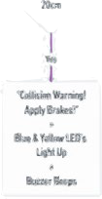

1

•·



*II*

.' ' ' .•.,.,.,.



l .

Vector file

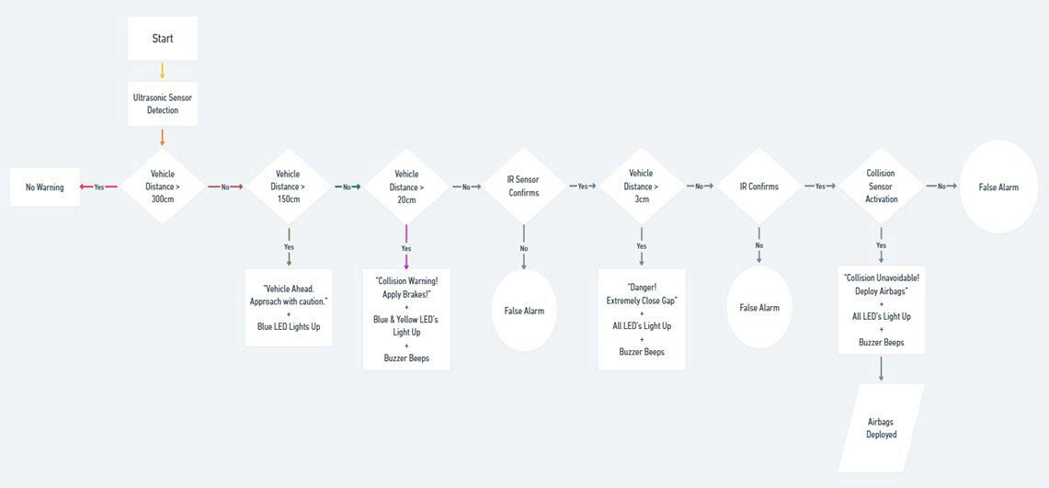

## EXPERIMENTAL SETUP

The project consists of the following components:

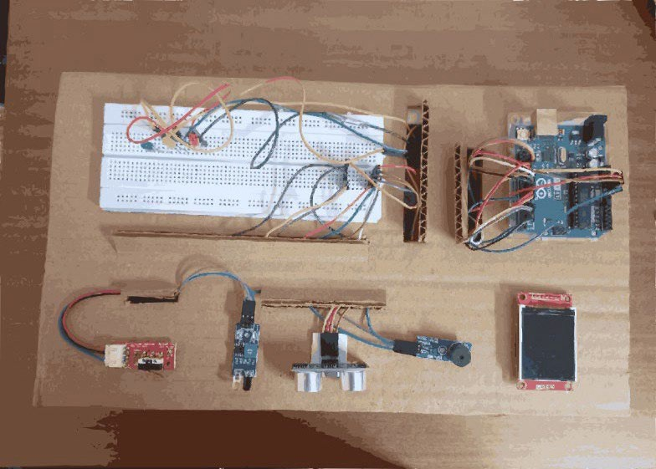

* + 1. Arduino Uno board

An Arduino is a microcontroller development board available as open-source. In simpler terms, it serves as a tool to read sensors and manage devices such as motors and lights. This capability allows you to upload programs onto the board, enabling it to interact with the physical world. Essentially, if something is electrically controlled, the Arduino can connect with it. Moreover, even if the object isn't electrically operated, we can likely use components like motors and electromagnets to establish a connection.

In this project, the Arduino board serves as the fundamental component for creating a traffic collision warning system, playing a central role in its development.

The Arduino Uno board has a variety of pins, each serving specific functions. Here's a brief overview of the different types of pins on an Arduino Uno:

* + - 1. Digital Pins (D0-D13): These pins can be configured as either input or output. They are used for digital communication and can be used to read digital sensors or control digital components.
      2. Analog Pins (A0-A5): These pins can be used to read analog sensor values. Although labeled as analog, they can also function as digital pins.
      3. Power Pins:

Vin: This is the voltage input pin. It can be used to supply an external voltage to the board. 5V: This pin provides a regulated 5V output.

3.3V: This pin provides a regulated 3.3V output.

GND: Ground pins for connecting to the ground of external components.

* + - 1. Reset Pin (RESET): This pin is used to reset the microcontroller.
      2. Communication Pins: Serial Communication:

TX (Transmit): Used for serial communication (sending data). RX (Receive): Used for serial communication (receiving data).

* + - 1. External Interrupt Pins (D2, D3): These pins can be used to trigger interrupts in response to external events.
      2. PWM (Pulse Width Modulation) Pins (D3, D5, D6, D9, D10, D11): These pins support analog output using PWM.
      3. I2C Pins (A4, A5): Used for I2C communication.
      4. SPI Pins (D10, D11, D12, D13): Used for SPI communication.
    1. Ultrasonic sensor:

It is an electronic device that measures the distance to an object by emitting ultrasonic waves and converting the reflected sound into electrical signals. It consists of two main components: a transmitter and a receiver. The principle is to measure the time it takes the signal sent by the transmitter and propagate back to the receiver.

The transmitter transmits an ultrasonic sound which will be reflected back if an object is present and received by the receiver.

The range of the sensor is 2cm to 400cm. Distance = Time * speed of sound/2

It consists of 4 pins

1. Vcc : operating power supply, connected to 5V of the Arduino board.
2. Gnd : common ground , connected to 5V of the Arduino board.
3. Trigger pin: to start the sensor, sends ultrasonic waves, connected to pin 6 of the Arduino board
4. Echo pin: receives the reflected signal, connected to pin 7 of Arduino board.
   * 1. InfraRed (IR) Sensor

IR sensor is a device that detects infrared radiation emitted by objects. It consists of an IR source, which emits infrared light, and a detector that picks up the reflected IR signals. Its range is upto 20cm only.

Here, it is used to detect the vehicle when it is extremely close.

There is onboard a potentiometer to adjust the detection range. There is an Obstacle Detection LED indicator on the module board.

It has 3 pins, Vcc, Gnd, and Out.

The out pin is set as input and connected to pin 12 of the Arduino board. It is active low, i.e., when the pin goes low, object is detected.

* + 1. Piezo Buzzer

Buzzers are electric sounding devices that generate sounds. The essential component of a piezo-type buzzer is its piezoelectric element, composed of piezoelectric ceramic and a metal plate. These elements are bonded together into a single unit using adhesive.

n this project, the piezo-type buzzer is employed in two different zones to provide warnings. In one zone, it emits a sound at half of its regular intensity, while in the other zone, it produces a sound with a frequency of 1000Hz.

It has 3 pins: Gnd, Vcc and I/O.

I/O is connected to pin 5 of the Arduino board and set as output.

* + 1. Impact Switch/Collision sensor

It is used for robot collision detection, and touch collision detection. It is based on the high-sensitivity crash sensor. With the Arduino sensor expansion board, in combination, it can be very easy to achieve traffic collision detection and touch collision detection. It is an active low sensor i.e. when collision is detected, the output pin goes low. The pins are: (1) Output (2) Vcc(5V) (3) Gnd

Vcc and Gnd are connected to 5V and Gnd of Arduino board respectively. Output is connected to pin 1 of Arduino board.

## LCD

It is a small and vibrant display incorporated into the project to provide appropriate warning signals in different zones. It communicates through 4-wire SPI, ensuring compatibility with a variety of

microcontrollers, including those with limited resources. The 1.8-inch TFT LCD Module provides a resolution of 128x160 pixels, utilizing true TFT technology for vivid visuals with an 18-bit color depth and 262,144 shades. The ST7735R TFT driver chip ensures consistent code performance. The LCD has a flex-circuit connector, a 3.3V regulator, and a 3/5V level shifter, allowing adaptability to different power and logic requirements. Additionally, it has a practical microSD card holder, which simplifies the process of loading full-color bitmaps from a formatted microSD card.

## LED

It is a device which emits light when current flows through it. LEDs produce different colours due to variations in the semiconductor materials used within the LED and the energy bandgap associated with those materials. In this project, three LEDs (red, blue, and yellow) are employed, with each LED illuminating in specific zones as required.

It has 2 pins, Gnd and Vcc.

Red LED is connected to pin 4 of Arduino board. Yellow LED is connected to pin 3 of Arduino board. Blue LED is connected to pin 2 of Arduino board

* + 1. Breadboard

A **breadboard** is a construction base used to build semi-permanent prototypes of electronic circuits.

# RESULTS AND DISCUSSIONS

* 1. INITIAL CONDITIONS

In response to the persistent issue of traffic collisions, a decision was made to initiate a project aimed at preventing these accidents. Through a thorough analysis of various scenarios, it became apparent that the distance between obstacles emerged as a crucial parameter for assessing the likelihood of collisions. Recognizing the significance of this factor, the project is poised to focus on leveraging the distance between obstacles as a key metric to evaluate and predict the potential occurrence of collisions. This approach reflects a strategic and data- driven effort to address and mitigate the challenges associated with traffic collisions by honing in on a fundamental aspect of spatial dynamics on the roadways.

There are several approaches available for determining the distance between our vehicle and the obstacle ahead. Whether the obstacle is stationary or in motion, distance sensors employ one of three methods: signal strength (measuring the reduction in emitted signal when reflected off a target), triangulation (calculating distance based on the angle at which the emitted signal is reflected off the target), or time of flight (measuring the time it takes for a signal to be emitted, reflected off the target, and received).

Building upon previous research in this domain, ultrasonic sensors emerge as a particularly efficient and dependable technology for calculating the distance between vehicles. Ultrasonic sensors operate on the principle of emitting ultrasonic waves and measuring the time it takes for the waves to bounce back after hitting an obstacle. This method provides a reliable means of determining distances, and their efficiency has been demonstrated in various studies. The utilization of ultrasonic sensors in calculating inter-vehicle distances underscores their effectiveness in contributing to improved safety and collision prevention in the field of automotive technology.

In conjunction with ultrasonic sensors, we sought to enhance accuracy by integrating infrared sensors into our system. Infrared sensors operate on the principle of detecting the infrared

rays emitted by objects. These sensors are particularly effective in short-range distances due to their limited range. By incorporating infrared sensors alongside ultrasonic technology, we aim to capitalize on the complementary strengths of both systems. While ultrasonic sensors excel in capturing longer-range data, infrared sensors provide heightened accuracy in short- range distances. This combined approach is designed to offer a comprehensive and robust solution for accurately measuring distances between objects, contributing to increased precision and reliability in our system.

## PARAMETERS INVOLVED

In the development of the collision prevention warning system, several parameters, such as distance, speed, and path detection, can be considered for implementation. Following a careful analysis of previous reports and studies, it has been determined that focusing on a system primarily centred around distance is likely to be particularly efficient. This choice is rooted in the recognition of distance as a critical factor in predicting and preventing potential collisions. By prioritizing the distance parameter within the system's framework, there is an intention to create an effective solution that contributes significantly to the overall safety of the road environment.

During the course of the project, it became apparent that the incorporation of a physical collision detector could be a valuable addition. This detector would be designed to trigger when the vehicle comes into physical contact with an obstacle. The introduction of such a detector serves as a concrete measure to ensure that a collision has indeed occurred. By activating a warning mechanism in response to physical contact, this approach provides a more direct and definitive indication of a collision, enhancing the system's ability to promptly alert and respond to potential accidents.

## SYSTEM ANALYSIS

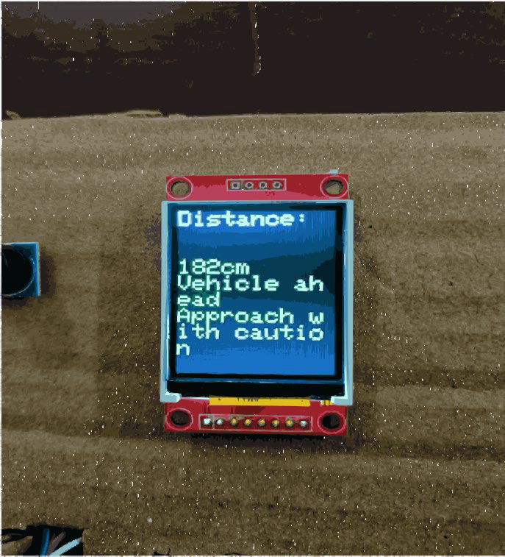Zone 1: < 300cm but >150cm

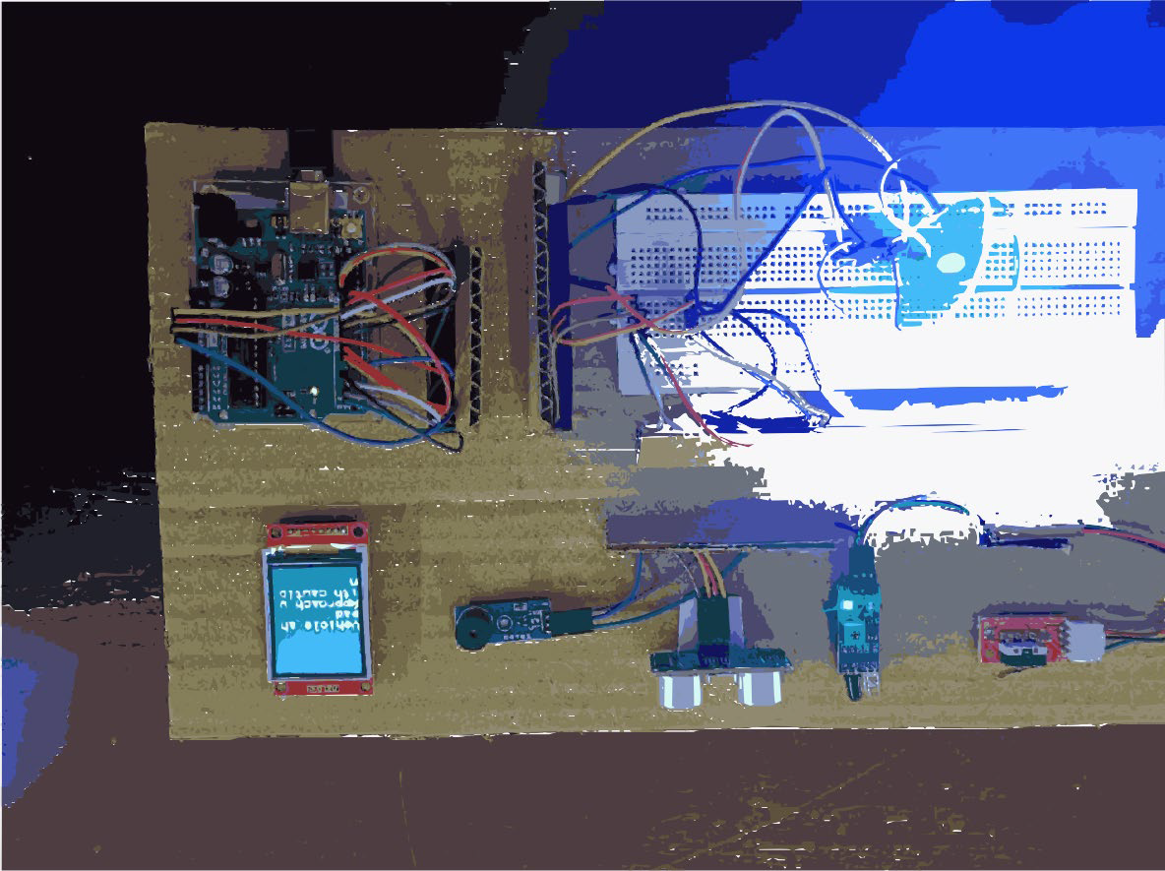

Zone 2: <150cm but >20cm

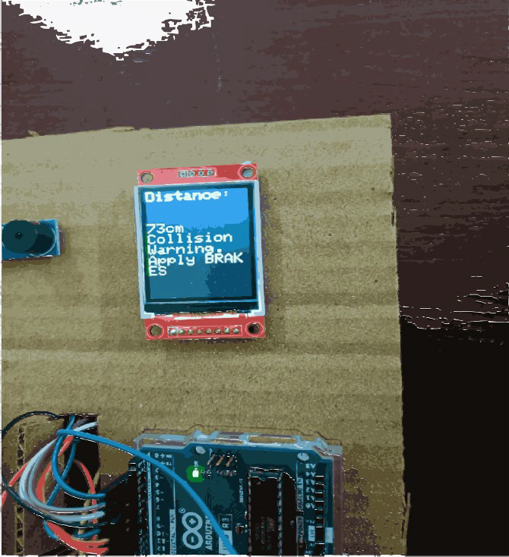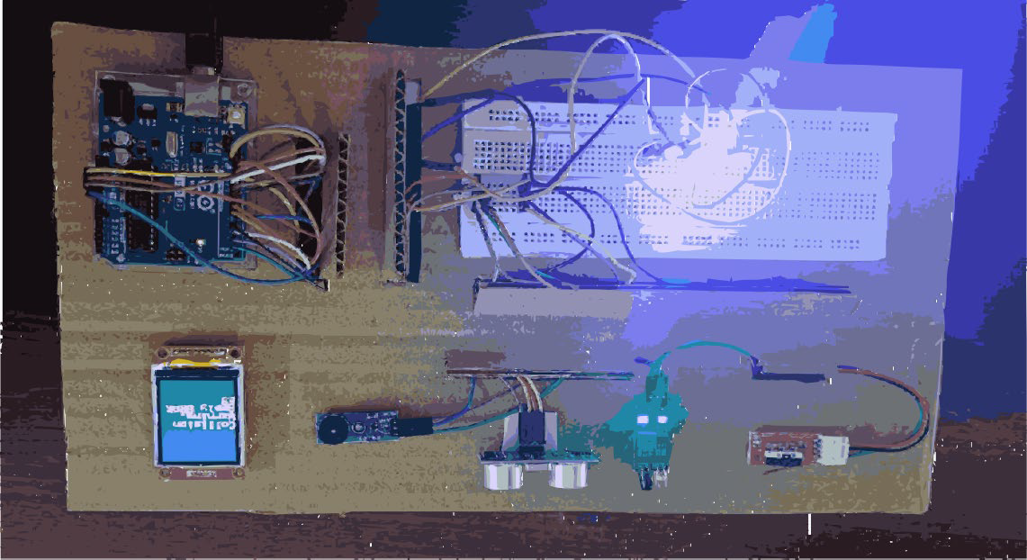

Zone 3: <20cm but >3cm

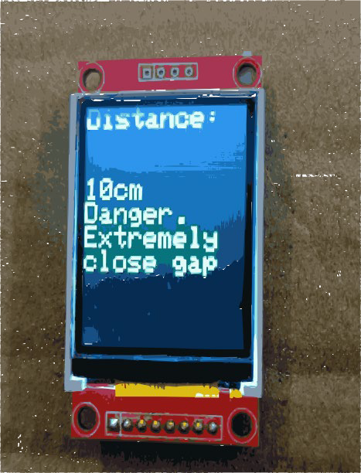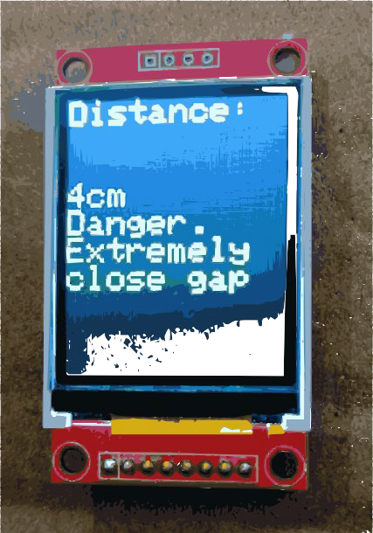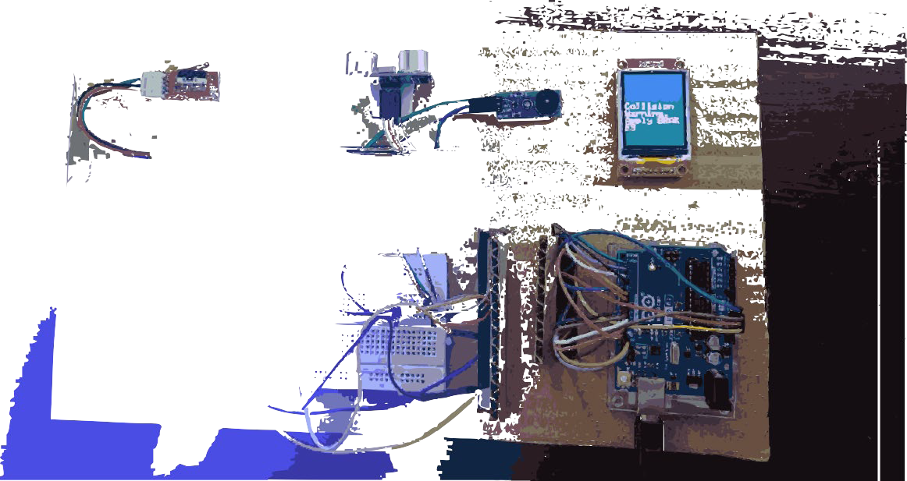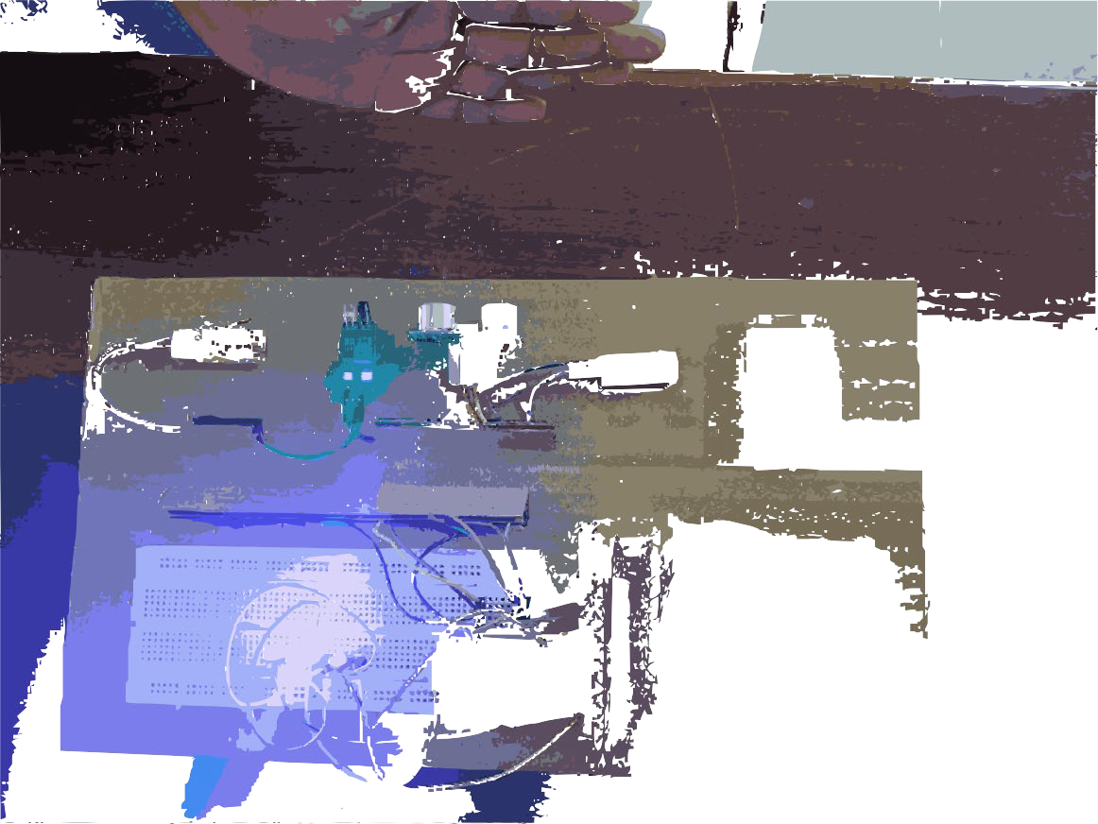

Zone 4: <=3cm or collision detector has detected collision

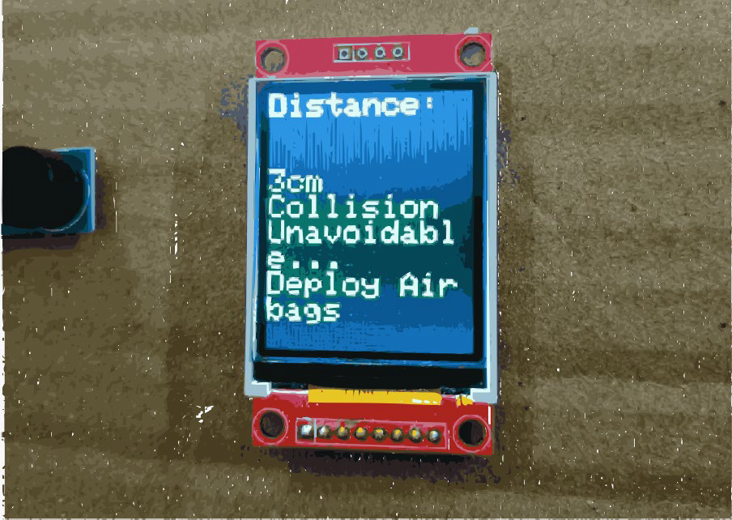

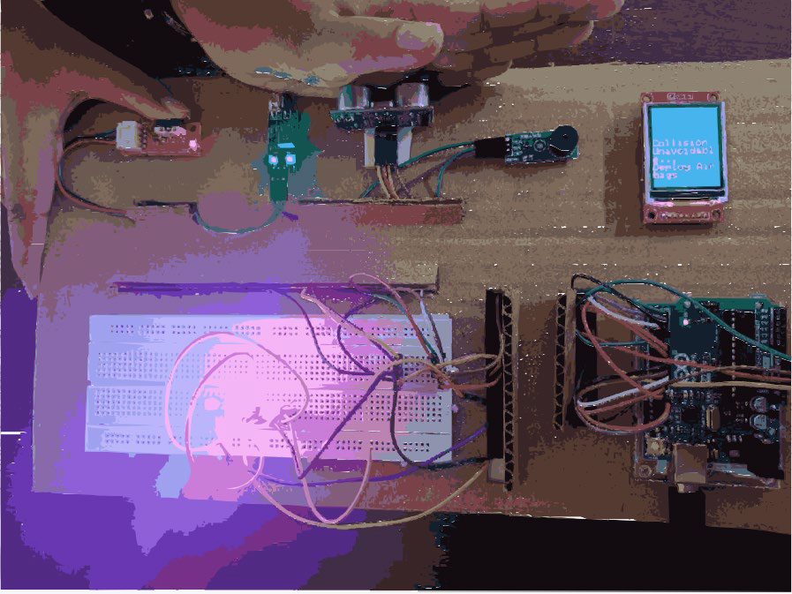

## RESULT ANALYSIS

The primary objective was to develop a warning system capable of accurately detecting the distance between obstacles and generating timely warnings. Through this endeavour, we achieved a maximum level of accuracy, with the system reliably detecting distances as close as 2 cm. Notably, our approach involved the utilization of three types of sensors, a combination that contributed to the heightened precision observed.

However, it's important to note that a slight delay of one second has been identified between the detection of distance and the display of the warning. This delay is attributed to the use of cost-effective materials in the system's construction. It is anticipated that by employing higher-quality components, this delay can be mitigated, enhancing the overall responsiveness and real-time nature of the warning display. The trade-off between cost-effectiveness and system performance is acknowledged, and improvements in the components can further refine the system's capabilities.

1. **Conclusion**

## DEMONSTRATION OF FINDINGS IN THE PAPER

The paper showcases a traffic collision warning system that uses three LEDs (red, blue, and yellow) to signify different danger zones based on the distance between vehicles. In Zone 1, the ultrasonic sensor triggers the blue LED when the distance is ≤ 300cm. Zone 2 (<150cm) activates both blue and yellow LEDs with a 1000Hz buzzer. Zone 3 (<20cm), identified by an infrared signal, illuminates all three LEDs with a half-intensity buzzer. Zone 4 (<3cm) triggers all LEDs and airbag deployment upon impact detection. Warning messages for each zone are displayed on an LCD screen, offering real-time alerts to enhance road safety through a comprehensive sensor and LED system.

## ANALYSIS AND NUMERICAL RESULTS

Tests were carried out to observe the system's performance across different zones, and the obtained results aligned with the theoretical expectations. The system demonstrated effective functionality in all four zones. Notably, a delay in displaying messages on the LCD screen was observed. This delay stems from the system's

computational process, taking time to calculate the distance between vehicles before presenting the warning message. Consequently, the warning displayed corresponds to the previously calculated distance, introducing a lag due to the processing time of hardware components. Unfortunately, no viable solution was identified to simultaneously display the current distance and a precise warning.

## CONCLUSIONS DRAWN FROM THE PROJECT

We observed that the system exhibited reliable detection capabilities even at remarkably close distances, accurately identifying objects as close as 2cm. The implemented safety measures were promptly triggered in response to such close proximity. It's noteworthy, however, that there was a noticeable delay in the display response. We observed that the system exhibited reliable detection capabilities even at remarkably close distances, accurately identifying objects as close as 2cm. The implemented safety measures were promptly triggered in response to such close proximity. It's noteworthy, however, that there was a noticeable delay in the display response.

## APPLICATION

* + 1. Vehicle Safety Systems: Integration of the proposed system into vehicles as part of an advanced safety package to alert drivers to potential collisions and mitigate risks.
    2. Fleet Management: Implementation in fleet vehicles to enhance safety and reduce the likelihood of collisions, particularly in scenarios involving multiple vehicles.
    3. Pedestrian Safety Systems: Implementation of the proposed traffic collision warning system in urban and pedestrian-heavy environments to enhance safety for pedestrians. The system can be adapted to detect and alert both drivers and pedestrians about potential collision risks, contributing to pedestrian safety in crosswalks, intersections, and crowded pedestrian areas
    4. Smart Cities: Inclusion as part of smart city initiatives, contributing to the development of intelligent transportation systems that prioritize road safety.
    5. Research and Development: Utilized as a platform for further research and development in the field of automotive safety, contributing to the ongoing advancements in collision avoidance technologies.
  1. Future Scope

To enhance the current setup, efforts should focus on reducing system lag and streamlining module size for quicker and simpler installations. If deemed successful, additional functionalities, such as alerting authorities and extending collision warnings to back-end and side collisions, could be considered. Customization for specific scenarios or vehicle types is also possible. Potential improvements may include refining the system to cater to distinct road scenarios and incorporating extra features for a more effective collision avoidance solution. Additionally, considering a 3D CAD model for the system allows for seamless installation in various vehicles, minimizing hardware connections and enhancing versatility.